JSONPlaceholder

🌟 Definition
# Source: AI Source: Provided by: [Data Path: Persons Table -> ID Column: 1, Name_En Column: Motasem Essam] -> From: [ChatGPT] on [6/2/2026]
JSONPlaceholder is a free online fake REST API service (Mock API) that provides ready-made JSON data for testing and learning API development.
It is used by developers to practice APIs without needing a real backend server.
Official website:
JSONPlaceholder

🎯 Purpose
# Source: AI Source: Provided by: [Data Path: Persons Table -> ID Column: 1, Name_En Column: Motasem Essam] -> From: [ChatGPT] on [6/2/2026]
JSONPlaceholder helps developers:
- Test REST APIs (GET, POST, PUT, DELETE)
- Learn JSON structure
- Practice frontend development
- Simulate backend responses
- Build and test applications without a real database

🌟 What is a Mock API?
# Source: AI Source: Provided by: [Data Path: Persons Table -> ID Column: 1, Name_En Column: Motasem Essam] -> From: [ChatGPT] on [6/2/2026]
A Mock API is a fake API that returns predefined data instead of real database data.
👉 JSONPlaceholder is one of the most popular mock APIs.

🔢 Main Features of JSONPlaceholder

1. 📥 Ready-made REST API Endpoints
# Source: AI Source: Provided by: [Data Path: Persons Table -> ID Column: 1, Name_En Column: Motasem Essam] -> From: [ChatGPT] on [6/2/2026]
It provides sample endpoints like:
- /posts
- /comments
- /users
- /albums
- /photos
- /todos

2. 🔄 Supports Full CRUD Testing
# Source: AI Source: Provided by: [Data Path: Persons Table -> ID Column: 1, Name_En Column: Motasem Essam] -> From: [ChatGPT] on [6/2/2026]
You can test:
- GET (Read data)
- POST (Create data)
- PUT (Update data)
- PATCH (Modify data)
- DELETE (Remove data)

3. 📦 Fake JSON Data
# Source: AI Source: Provided by: [Data Path: Persons Table -> ID Column: 1, Name_En Column: Motasem Essam] -> From: [ChatGPT] on [6/2/2026]
Example response:
{
"id": 1,
"name": "Leanne Graham",
"username": "Bret"
}

4. ⚡ No Setup Required
# Source: AI Source: Provided by: [Data Path: Persons Table -> ID Column: 1, Name_En Column: Motasem Essam] -> From: [ChatGPT] on [6/2/2026]
- No database
- No server setup
- No authentication required
- Works instantly in browser or tools

5. 🌐 Cross-Platform Usage
# Source: AI Source: Provided by: [Data Path: Persons Table -> ID Column: 1, Name_En Column: Motasem Essam] -> From: [ChatGPT] on [6/2/2026]
You can use it with:
- JavaScript (fetch)
- cURL
- Postman
- Insomnia
- PHP
- Python

📚 Example API Endpoints
# Source: AI Source: Provided by: [Data Path: Persons Table -> ID Column: 1, Name_En Column: Motasem Essam] -> From: [ChatGPT] on [6/2/2026]

1. 👤 Users API
JSONPlaceholder Users

2. 📝 Posts API
JSONPlaceholder Posts

3. 💬 Comments API
JSONPlaceholder Comments

4. 📷 Photos API
JSONPlaceholder Photos

5. ✔️ Todos API
JSONPlaceholder Todos

🔗 Example Usage (JavaScript)
# Source: AI Source: Provided by: [Data Path: Persons Table -> ID Column: 1, Name_En Column: Motasem Essam] -> From: [ChatGPT] on [6/2/2026]
fetch("https://jsonplaceholder.typicode.com/users")
.then(response => response.json())
.then(data => console.log(data));

📡 How JSONPlaceholder Works
# Source: AI Source: Provided by: [Data Path: Persons Table -> ID Column: 1, Name_En Column: Motasem Essam] -> From: [ChatGPT] on [6/2/2026]
Frontend / Tool
↓ request
JSONPlaceholder API
↓ response (JSON data)
Frontend displays data

🧠 Simple Analogy
# Source: AI Source: Provided by: [Data Path: Persons Table -> ID Column: 1, Name_En Column: Motasem Essam] -> From: [ChatGPT] on [6/2/2026]
Think of JSONPlaceholder like:
🏪 A fake online store
- Products = fake data
- API = shelves you can access
- You can test everything without buying or building anything

⚖️ Why Developers Use It
# Source: AI Source: Provided by: [Data Path: Persons Table -> ID Column: 1, Name_En Column: Motasem Essam] -> From: [ChatGPT] on [6/2/2026]
- Learn API development safely
- Test frontend apps
- Practice fetching JSON
- Prototype applications quickly
- No backend needed

Run JSONPlaceholder
# Source: ScreenShot Source: Provided by: [Persons Table -> ID Column: 1, Name_En Column: Motasem Essam] -> Tool: [Automation Table -> ID Column: 16, Name_En Column: Screen Capture] -> From [Site: Google Search: All: JSONPlaceholder] on [6/2/2026]
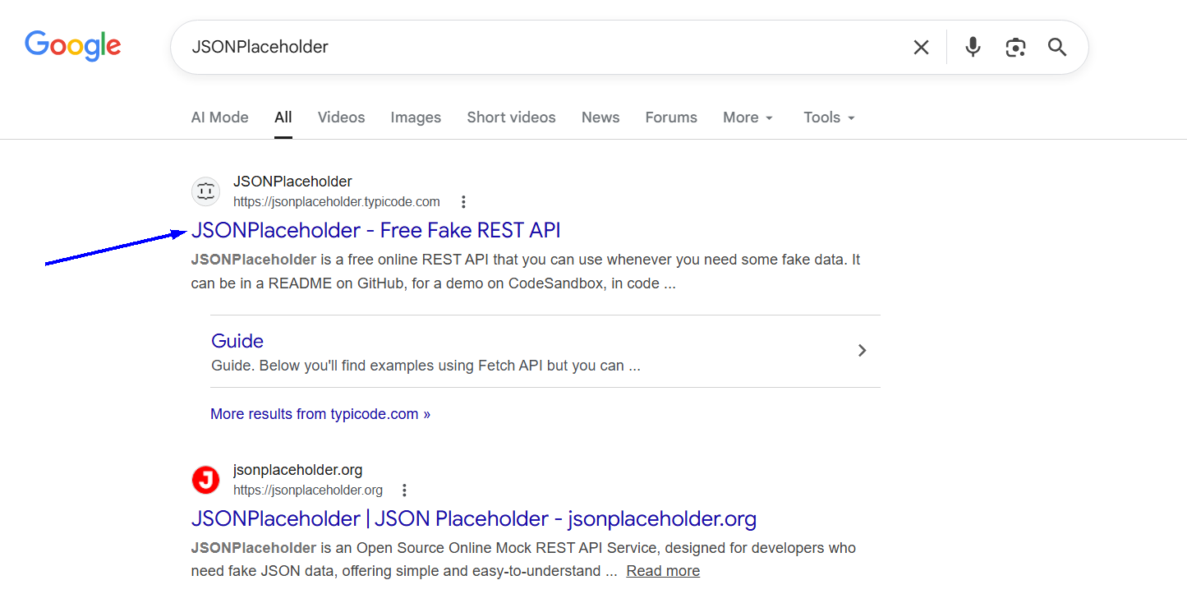
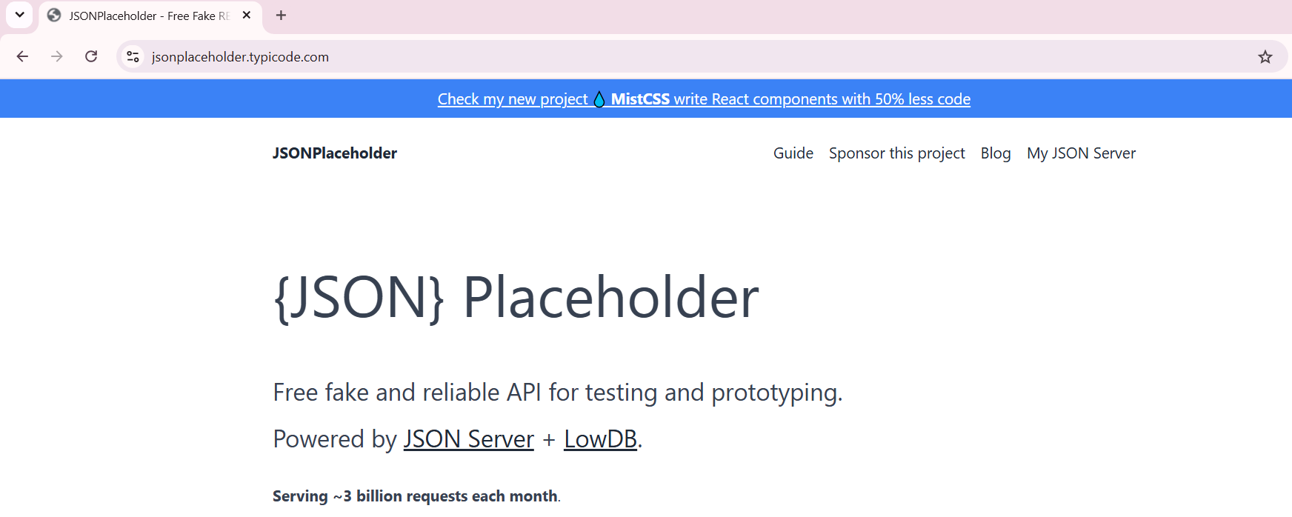
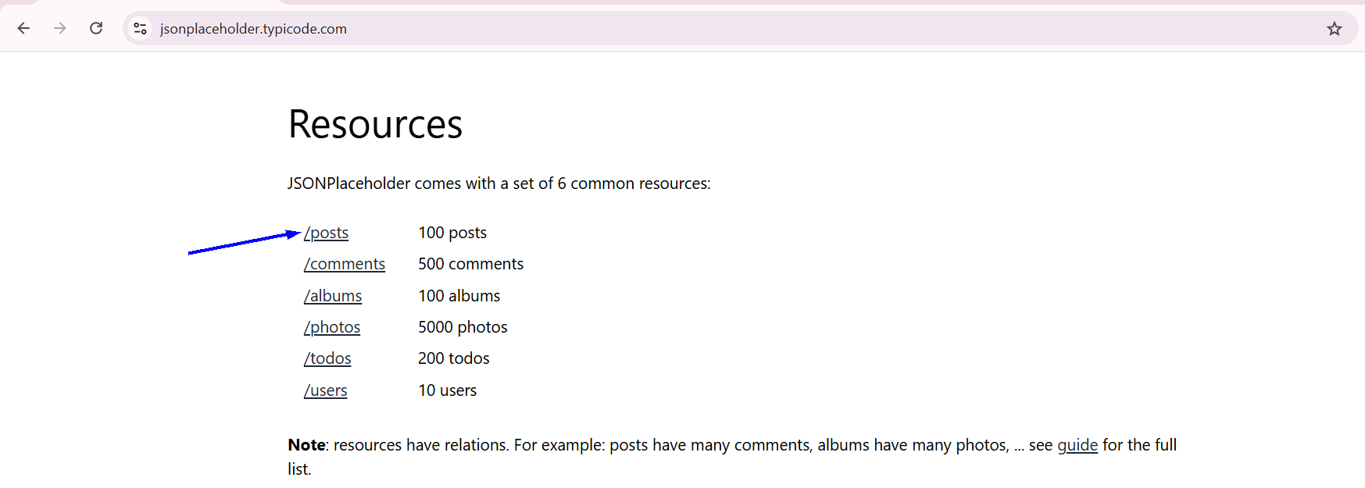
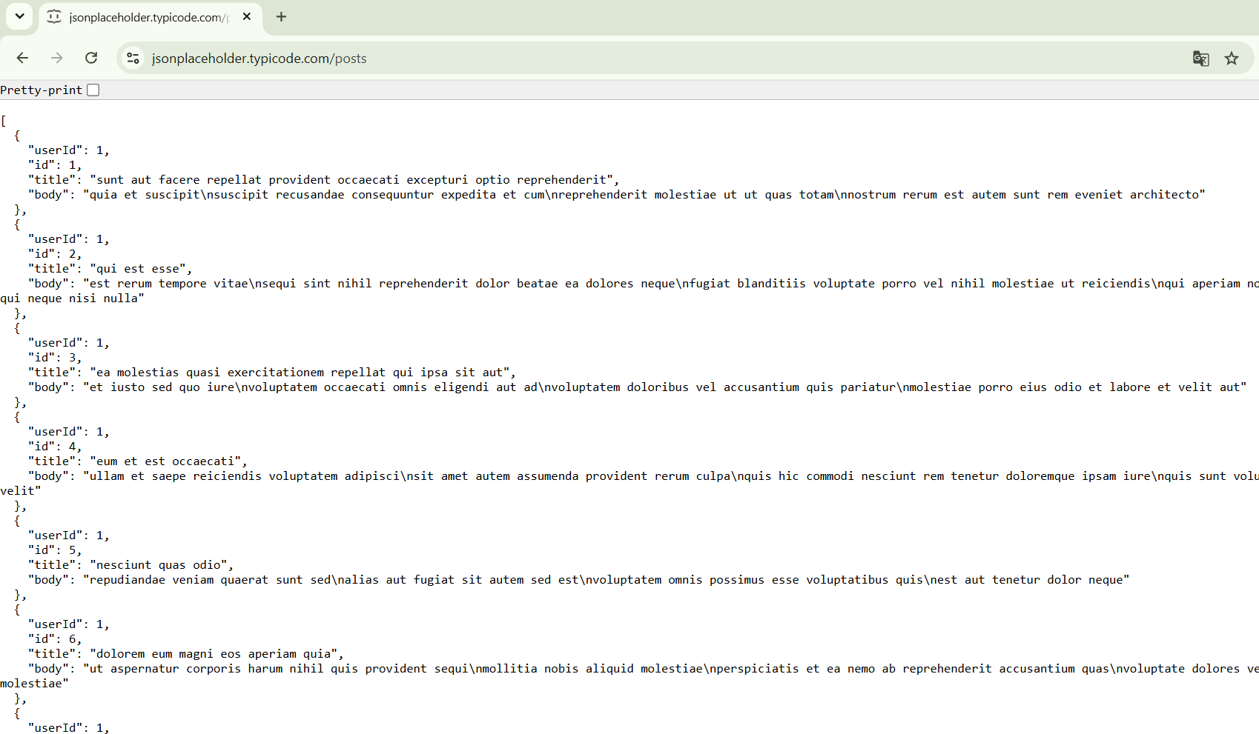
https://jsonplaceholder.typicode.com/posts

🧭 Summary
# Source: AI Source: Provided by: [Data Path: Persons Table -> ID Column: 1, Name_En Column: Motasem Essam] -> From: [ChatGPT] on [6/2/2026]
JSONPlaceholder is a free mock REST API service that provides fake JSON data and endpoints so developers can practice, test, and build applications without needing a real backend server.

